# 

Table des matières

[Thermostat documentation 2](#_Toc503170364)

[What is the purpose? 2](#_Toc503170365)

[The services 2](#_Toc503170366)

[The basic services 2](#_Toc503170367)

[The extended services 3](#_Toc503170368)

[Architecture overview 5](#_Toc503170369)

[Technical implementation 6](#_Toc503170370)

[Heating regulation 6](#_Toc503170371)

[Heating instruction 6](#_Toc503170372)

[Hardware design 6](#_Toc503170373)

[Network connection 9](#_Toc503170374)

[Server components 10](#_Toc503170375)

[DIY instructions 11](#_Toc503170376)

[Build of material 11](#_Toc503170377)

[Build the power sources 12](#_Toc503170378)

[Build the electronics 12](#_Toc503170379)

[Let’s do with the gateway configuration 15](#_Toc503170380)

[Let’s do with the Arduino side 19](#_Toc503170381)

[Solder the components 24](#_Toc503170382)

[Solder the power supply 24](#_Toc503170383)

[28](#_Toc503170384)

[User guide 33](#_Toc503170385)

[How to install the server code 34](#_Toc503170386)

[Start your IDE environment 34](#_Toc503170387)

[Create the database tables 34](#_Toc503170388)

[Maintenance guide 38](#_Toc503170389)

[Diagnostic 38](#_Toc503170390)

[Diagnostic byte 39](#_Toc503170391)

[Modify WIFI SSID 39](#_Toc503170392)

[Download a new Arduino code. 40](#_Toc503170393)

[Download a new Gateway code. 40](#_Toc503170394)

[How to set the serial switches 40](#_Toc503170395)

[System tunning 41](#_Toc503170396)

[Commands 42](#_Toc503170397)

[An open system 43](#_Toc503170398)

[Change than can be done easily 43](#_Toc503170399)

[Improvements that could be done 43](#_Toc503170400)

[Communication specifications 43](#_Toc503170401)

# Thermostat documentation

### What is the purpose?

* Increase the comfort by heating your house exactly as you want
* Make savings by heating your house only when you need and reduce greenhouse gas emissions
* Control on your heating wherever you are
* Be proud you did it by yourself

## The services

### The basic services

Heating regulation algorithm adjusted to the environment provides a very stable temperature.

Heating instructions are defined on schedules based on weekly and daily calendars.

For instance:

* a weekly calendar schedule used during the working periods
* a daily schedule used when you are on holidays at home
* another daily schedule when you are out of home for the day

User expresses instruction as an objective couple (temperature,time) . For instance: I want 20° at 8:30. The thermostat will do it best to reach the expected temperature at the wished time.

The thermostat will start heating at the appropriate time depending on the inside and outside actual temperatures

Regulation relays on 2 points

* A PID controller to provide temperature stability

|  |  |
| --- | --- |
| **Temperature Instruction**  **Actual temperature**  **Heating On/Off** |  |

* An instruction controller to optimize heating

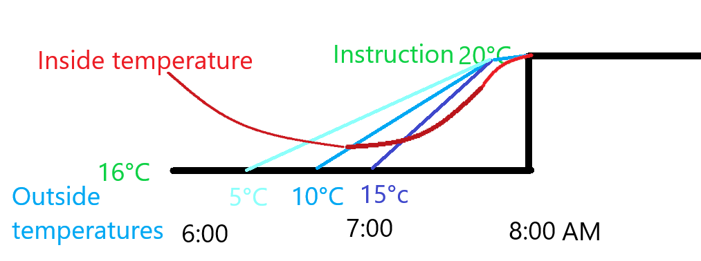

User can at any time, either with a remote controller or with the WEB HMI

* switch between the different schedule modes
* manually modify temperature instruction
* temporarily hold on the heating system

### The extended services

Even if the thermostat can work 100% autonomously its purpose is to be connected to provide additional services when connected to WIFI.

A Web application can be used for the user to monitor and control the heating. For instance, you will be able to increase the temperature remotely with your mobile on you way back from holiday.

The thermostat will provide a lot of information that could be used to better tune your installation and so increase your comfort and savings. Parameters can be modified remotely.

The clock of the thermostat is synchronized with the server and will automatically switch for the daylight saving time (summer time).

The thermostat can receive some external information to adjust temperature instruction to external conditions: for instance, decrease temperature when you are out and have set your home is under alarm system.

By adding a micro-controller with 2 sensors the HMI will show you the go and return the boiler water temperature. That will help you to tune the boiler heating and keep return temperature below the dew point.

## Architecture overview



Internet WIFI

Router

Server

Tomcat Linux

WIFI Gateway

ESP8266

Micro Controller

Atmel ATmega

Boiler

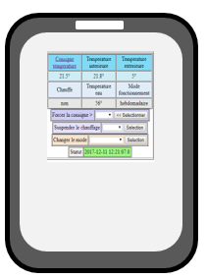

## Technical implementation

The core system runs on an Atmel ATmega micro-controller. It has been validated on the following Arduino platforms: Nano, Uno and Mega). After code and parameters has been downloaded the Arduino and clock synchronized with the server, it can run 100% autonomously. It communicates thru the serial link to take into account external information.Parameters are initially written in the Eeprom and can be modified remotely and saved in the Eeprom.

A ESP8266 micro-controller runs the gateway code for transforming serial link connection to a WIFI one.

Java runs the server part of the system. HMIs use TOMCAT. MySQL is the database.

### Heating regulation

Temperature is driven by a PID regulator. The PID parameters (KpPID,KiPID,KdPID, thresholdPID, PIDCyleDelay) are initially defined when downloading the code and can be adjusted remotely. When the thermostat is set in trace PID mode,it continuously sends information to the server that are useful to adjust the PID parameters to your equipment.

A timer parameter (hysteresisDelay) is used to avoid to switch the boilier on/off too fast.

Internet provides actual external temperature at your location.

### Heating instruction

Even if temperature can be set manually, the purpose of the thermostat is to run in automatic mode.

The system will switch between 4 different temperature instructions (for instance T0=morning, T1=day, T2=evening, T3=night) according to your need. Your need has to be defined in 1 weekly and 2 daily schedules. For each half an hour you have to select one of the 4 temperature instructions. The schedule has to be downloaded with the code but can be modified remotely and saved in the eeprom.

A 5th temperature instruction is used when you are out of home to keep your house out of freeze.

Temperature instructions are expressed as targets (be at a temperature at a definite time). To decide when to start heating the thermostat will take into account the actual internal temperature, the target and the actual outside temperature. This regulation can be tuned to your need with the "Reactivity" parameter that you can modify remotely and save in the eeprom. Each hour instruction is one byte coded: the first half byte is used to select the instruction for the first half hour and the second half byte is used to select the instruction for the second half hour. For instance, 0x12 means select temperature T1 between 0 to 29mn and temperature T2 between 30 to 59mn.

2 parameters (maximumTemperature, minimumTemperature) define the maximum and minimum temperature than can be set by the user. It can be modified remotely and save in the eeprom.

### Hardware design

#### Boiler connection

Boiler is connected to a NO relay. The heating is set on by closing the relay and of by opening it.

#### Power

Power source can be delivered by any not regulated 9v DC 500mA. All components are soldered on a PCB. It delivers the original not regulated 9v voltage, a 5v and 3.3v regulated voltage. 3.3v go thru a NC relay to allow the Arduino to switch 3.3v On/Off. 2 diodes protect from wrong input connection.

9v powers the Arduino (VIN).

5v powers the 2 relays, the clock, the LCD, the LEDs and the infrared receiver.

3.3v power the ESP8266

The temperature sensor is directly powered by the Arduino 5v output.[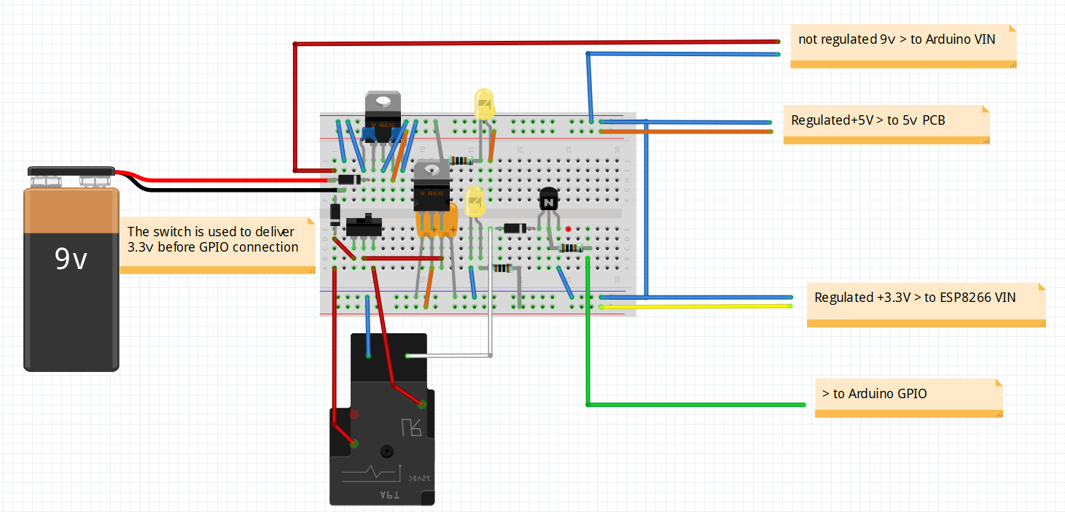](https://github.com/cuillerj/Thermostat/blob/master/thermostatPower.fzz)

#### Electronics

Arduino is protected from relays by NPN transistors and diodes.

ESP8266 RX (3.3v) is protected from Arduino TX(5v) by a voltage divider.

A push button allows to download ESP8266 program

2 connectors are used to switch the ESP8266 serial link from Arduino to the FTDI.

1 switch is used to set the ESP8266 in configuration mode

1 connector is used to initialize the Arduino

Arduino deals with digital GPIO, serial link, One wire bus and I2C bus.

The design allows to replace easily all the active components.

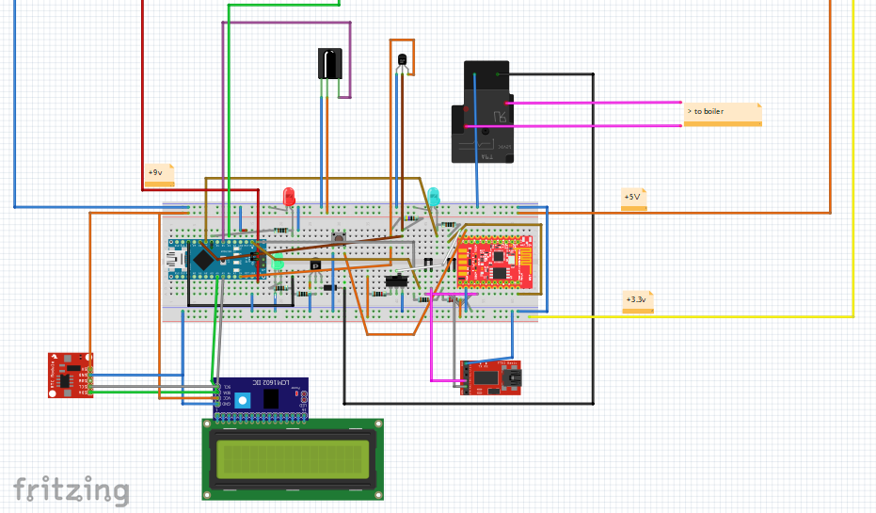

### Network connection

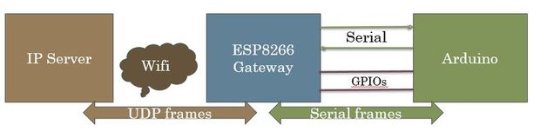

The network connection is made with a ESP8266 WIFI microcontroller. It is quite the same as the [gateway description “instructables”](https://www.instructables.com/id/How-to-Make-Your-Own-WIFI-Gateway-to-Connect-Your-/) . Nevertheless the following changes have been made from this description: some useless GPIOs for this project are not used and the Arduino and ESP8266 are soldered on the same PCB.

This module is connected from one side with the serial link from the other side to IP network with the Wifi. It acts as a black box. Data packets coming from the serial link are sent to an IP/Udp port and vis et versa. It can transfer either ASCII and binary data.

You just have to set your own configuration (IP, WIFI ...) once the first time you will power on the Gateway. This gateway configuration can be changed locally with USB TTY interface ([see maintenance guide)](#_How_to_set). Configuration is saved in eeprom.

A simple protocol is used between Server and Arduino as follow

* end to end 8bit CRC to check frame integrity
* send and receive frame numbers to check for missing frame
* frame sent can request or not an acknowledgement from receiver

Both Server and Arduino can initiate an exchange

* send information without being ask for
* send a request
* send a response to a request

[See communication specifications](#_Communication_specifications)

## Server components

Server runs Linux (developed with Ubuntu 14.04), mySQL server (developed with 5.5 version) and Tomcat7.

Java Batch is in charge of communication with the Thermostat.

It reads “meteo” table to look for the actual outside temperature and prepare data to send to the thermostat

It reads “ind\_desc” table to find parameter’s values that eventually need to be sent to the thermostat

It writes in “ind\_value” table parameter’s values and mesurments received from the thermostat.

J2EE application is in charge of human interface. It reads and updates database. It also sends command to the thermostat going thru the Java batch.

Thermostat

Read

Write

Request

Response/Information

Web application

J2EE

meteo

Ind\_value

Ind\_desc

Batchs

Java

## DIY instructions

The first step is to gather all the parts you will need.

### Build of material

**You will need these main components**

*2 x micro-controllers*

* + 1 x Arduino - I chose a Nano 3.0 - you can find some at around 2.5$ (Aliexpress)
  + 1 x ESP8266 - I [chose -ESP8266-DEV Olimex - at 5.5€](https://www.olimex.com/Products/IoT/MOD-WIFI-ESP8266-DEV/open-source-hardware)

*1 x temperature sensor DS1820*

* I chose a waterproof one - you can get 5 for 9€ (Amazon)

*1 x double relay module (0 command)*

* I chose SONGLE SRD-05VDC - you can find some at 1.5€ (Amazon)

*1 x I2C LCD 2x16 characters*

I already had one - you can find some for less than 4$ (Aliexpress)

*1 x I2C*DS1307 *Real Time Module with CR2032 battery*

* I already had one - you can find some for less than 4$ (Aliexpress)

*you can find for a few euros*

*1 x Infrared receiver*

* I chose AX-1838HS you can find 5 for 4€

1 x FTDI

1 x IR remote controller (you can buy a dedicated on or use your TV one)

*2 x power regulators (3.3v & 5v)*

* I chose I x LM1086 3.3v & 1 x L7850CV 5v

**And some few stuff**

5 x LED

9 x 1K resistors

1 x 2.2K resistor

1 x 4.7K resistor

1 x 100 microF ceramic capacitor

1 x 330 microF ceramic capacitor

2 x 1 microF tentalum capacitor

2 x NPN transistors

4 x Diodes

2 PCB breadboard

2 x 3 pins switches

Some connectors and wires

Of course you need soldering iron and tin.

### Build the power sources

[This fritzing file describes what to do.](https://github.com/cuillerj/Thermostat/blob/master/thermostatPower.fzz)

It is better to start to build the power sources with a breadboard even if there are no difficulties.

[](https://github.com/cuillerj/Thermostat/blob/master/thermostatPower.fzz)

Regulators can easily be replaced by other ones: just modify connections and capacitors according to your regulators characteristics.

Check it delivers a constant 5v and 3.3v even with a load (100 ohms resistors for instance).

You can now solder all the components on a breadboard PCB as below.

### Build the electronics

[This fritzing file describes what to do.](https://github.com/cuillerj/Thermostat/blob/master/thermostatElectronic.fzz)

I strongly suggest starting to build the electronics with a breadboard.

#### But even with the breadboard you will have to do some soldering as a first step.

Actually, the ESP8266-Dev from Olimex is coming as below

|  |  |
| --- | --- |
|  |  |

Plug your ESP8266 in a breadboard for an easiest soldering a below

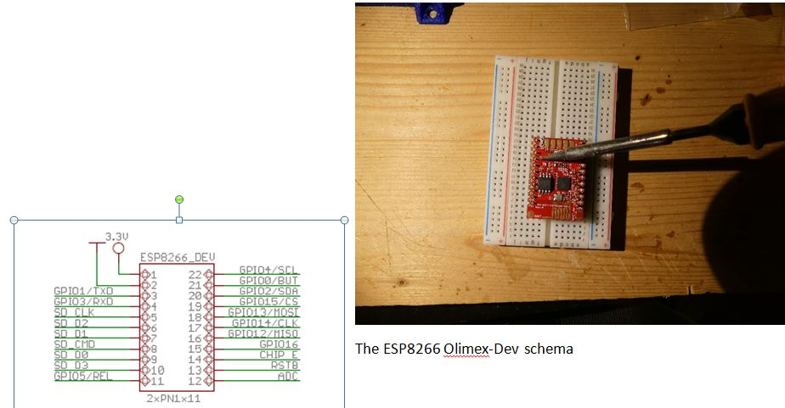

#### Now you are ready to put it all together on the breadboard

[Reproduce the Fritzing reference.](https://github.com/cuillerj/Thermostat/blob/master/thermostatElectronic.fzz)

There is no specific difficulty. Just take your time and check twice!

[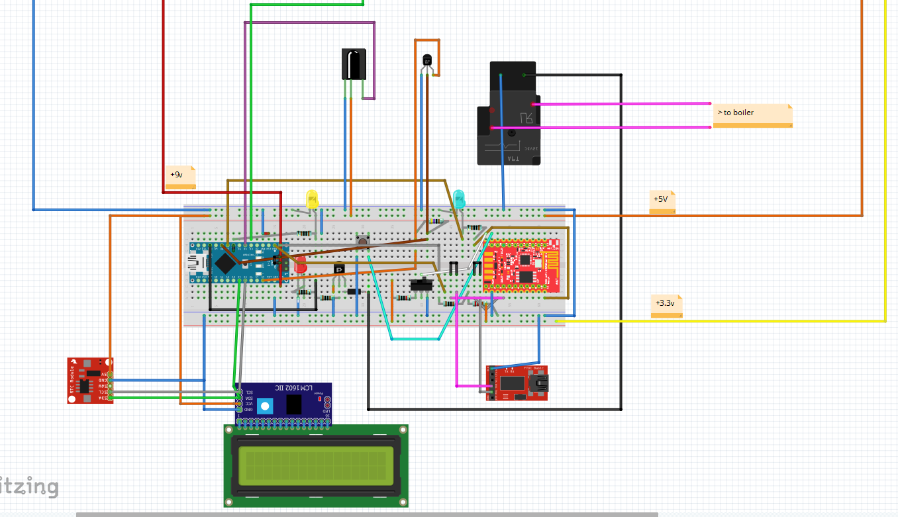](https://github.com/cuillerj/Thermostat/blob/master/thermostatElectronic.fzz)

#### Connect carefully power sources

Check power LEDs on the Arduino and ESP8266.

The LCD must light on.

### Let’s do with the gateway configuration

#### Connect the FTDI USB to your development station.

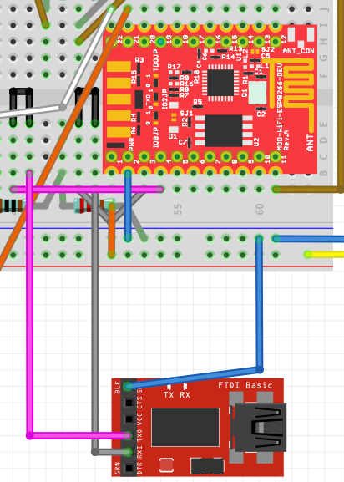 Set the serial link switch in order to connect ESP8266 to the FTDI as this

#### Prepare to download the gateway code

Start Arduino on your workstation.

You need ESP8266 to be known as board by the IDE.

Select the USB port and the appropriate board with Tools / boards menu.

If you do not see any ESP266 in the list that means you may have to install ESP8266 Arduino Addon ([you can find here the procedure](https://github.com/esp8266/Arduino#installing-with-boards-manager)).

All the code you need is available on GitHub. It is time to download it !

The main code of the Gateway is there: [https://github.com/cuillerj/Esp8266IPSerialGateway...](https://github.com/cuillerj/Esp8266IPSerialGateway/blob/master/Esp8266IPSerialGateway.ino)

On top of standard Arduino and ESP8266 includes the main code need these 2 includes:  
LookFoString that is used to manipulate strings and is there: <https://github.com/cuillerj/LookForString>

ManageParamEeprom that is used to read and store parameters in Eeprom ans is there: <https://github.com/cuillerj/ManageParamEeprom>

Once you get all the code it's time to upload it into the ESP8266.  
First connect the FTDI to an USB port of your computer.

I suggest you check the connection before trying to upload.

* Set the Arduino serial monitor to the new USB port.
* Set the speed to 115200 both cr nl (defaut speed for Olimex)
* Power on the breadboard (ESP8266 comes with software that deals with AT commands)
* Send "AT" with the serial tool.
* You must get "OK" in return.

If not check your connection and look at your ESP8266 specifications.

**If you got "OK" your are ready to upload the code**.

#### Download the gateway code

* Power off the breadboard, wait a few seconds,
* press on the push button of the breadboard and power on.

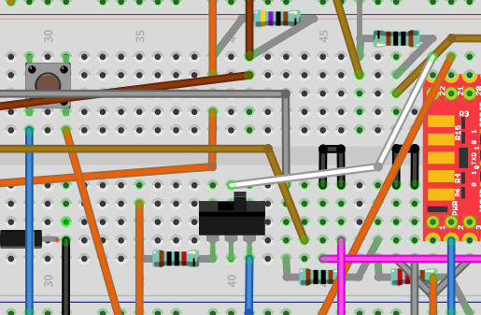

* release the push button It is normal to get some garbage on the serial monitor.
* Press on the upload IDE as for an Arduino.
* After the upload completed set serial speed to 38400.

You will see something as in the picture. 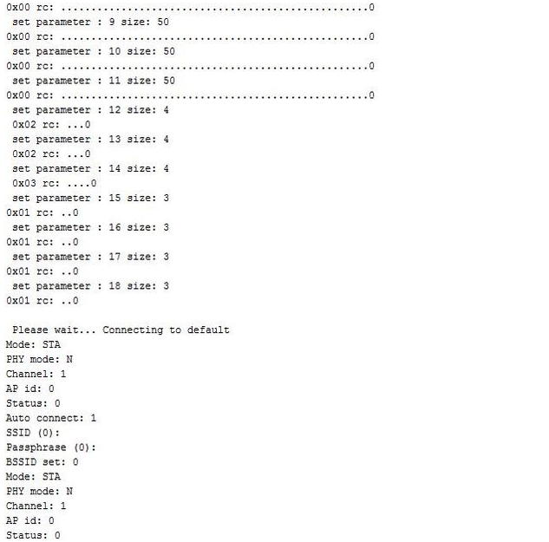

Congratulation you successfully uploaded the code !

#### Set your own gateway parameters

* Keep opened the Serial Monitor (speed 38400) of the IDE
* Power off the breadboard, wait a few seconds
* Use the switch to set the configGPIO to 1 (3.3v)

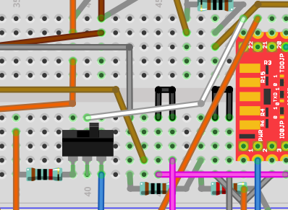

Scan the WIFI by entering the command: ScanWifi. You will see a list of the detected network.

* Then set your SSID by entering "SSID1=yournetwork"
* Then set your password by enterind "PSW1=yourpassword"
* Then enter "SSID=1" to define the current network
* Enter "Restart" to connect the Gateway to your WIFI.
* You can verify you got an IP by entering "ShowWifi".
* The blue LED will be on and the red LED blinking.

It's time to define your IP server address by entering the 4 subaddresses (server that will run the Java test code). For instance for IP=192.168.1.10 enter :

* "IP1=192"
* "IP2=168"
* "IP3=1"
* "IP4=10"

Define IP ports as:

* routePort=1840 (or else according to your application configuration see “Server installation guide”)

Enter "ShowEeprom" to check what you just stored in Eeprom

Now set the GPIO2 to ground to leave the configuration mode (use the switch to do so)

Your Gateway is ready to work !

The blue LED must go on as soon as the gateway is connected to your WIFI.

*There are some others commands you could find in the gateway documentation.*

## Let’s do with the Arduino side

Before working with the Thermostat code let’s do some tests with the IDE example sources

Firstly, unplug the serial link connectors to avoid USB conflict.

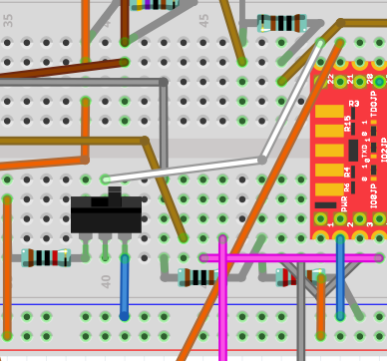

Connect the Arduino USB to your workstation.

Chose Serial Port, set speed to 9600 and set card type to Nano.

#### Check the temperature sensor

Open Files/ examples /Max31850Onewire / DS18x20\_Temperature and modify OneWire ds(8); (8 instead of 10).

Upload and check it works. In case not check your DS1820 connections.

#### Check the clock

Open Files/ examples / DS1307RTC / setTime program

Upload the code and check you get the right time.

#### Check the LCD

Open Files/ examples / liquid cristal / HelloWorld program

Upload the code and check you get the message.

#### Check the remote control

Open Files/ examples / ArduinoIRremotemaster / IRrecvDemo program

Modify the PIN to 4 – upload the code

Use your remote controller and check you get the IRs code on the monitor.

It is time to choose the remote control 8 different keys you want to use as below:

* increase temperature instruction
* decrease temperature instruction
* switch off the thermostat
* select the week agenda mode
* select the first day agenda mode
* select the second day agenda mode
* select the not freezing mode
* power on/off the WIFI gateway

Since you made your choice use the key, copy and save in a text document the received codes. You will need this information later.

#### Check the network connection

To check your work the best is to use the Arduino and Java examples.

##### Arduino

You can download it there: <https://github.com/cuillerj/TestSerialLinkLibrary>

It includes SerialNetwork library that is here: <https://github.com/cuillerj/SerialNetwork>

Just upload the code inside your Arduino.

##### Server

The server example is a Java program that you can download here: [https://github.com/cuillerj/ESP8266SerialUdpGatewa...](https://github.com/cuillerj/ESP8266SerialUdpGatewayExample/blob/master/src/ESP8266SerialUdpGatewayExample.java)

Just run it

Look at the Java console.

Look at the Arduino monitor.

Arduino send 2 different packets.

* The first one contains the digital pins 2 to 6 status.
* The second one contains 2 random values, the voltage level of A0 in mV and incremental count.

The Java program

* print the received data in hexadecimal format
* reply to the first kind of data with a random on/off value to set on/off the Arduino LED
* reply to the second kind of data with the received count and a random value.

You must see something like this.

|  |  |
| --- | --- |
| Arduino console | Java console |
|  |  |

**You are now ready to work on Thermostat code!**

Thermostat sources are available on GitHub

First [download this library](https://github.com/cuillerj/thermostatParameters) and copy files in your usual library.

[Then download these sources](https://github.com/cuillerj/Thermostat/blob/master/thermostatElectronic.fzz) and copy files in your usual Arduino sources folder.

Open Thermosat.ico and compile and check you do not get errors

Connect the Arduino USB to your workstation.

Set speed to 38400.

We need to set the Arduino in configuration mode

Plug a connector on the ICSP so that GPIO 11 is set to 1 (5v)

|  |  |
| --- | --- |
|  |  |

Upload the Arduino code.

The Arduino will start automatically.

Wait for the message “end init eeprom".

The default parameter’s values are now written in the eeprom.

Plug the connector on the ICSP so that GPIO 11 is set to 0 (ground) to set the Arduino in running mode.

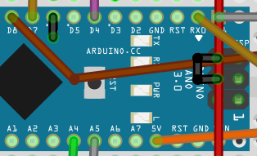

Reset the Arduino.

You must see time on the LCD and the yellow LED must be on. (You will see 0:0 if the clock has not be synchronized or time lost (powered of and no battery)).

After a few seconds you will see alternatively this kind of screen on the LCD.

|  |  |
| --- | --- |
| Screen 1 | Screen 2 |

**Look at the LCD.**

You will see alternatively 3 different screens. I will describe the 2 above. The 3rd one is described in the maintenance guide.

Common to screen 1 & 2:

* at the left of the top: the actual time
* at the left of the bottom: the actual temperature instruction
* at the middle of the bottom the: actual inside temperature (DS1820)

Screen 1:

* at the middle of the top: actual running mode

Screen 2:

* at the middle of the top: actual day of the week
* at the right of the top: day & month numbers

#### Test the relays

##### Test the Gateway relay

At this stage you must be WIFI connected and the blue LED must light on.

Press the remote controller key you selected to power on/off the WIFI gateway. The relay must switch off the ESP8266 and the blue LED.

Wait a few seconds and press again the remote controller key. The WIFI gateway must be powered on.

Within a minute le the gateway must be connected, and the blue LED must light on.

##### Test the boiler relay

First look at the red LED. If temperature instruction is much higher than the inside temperature the LED must light on. It takes a few minutes after the start for the Arduino to get enough data to decide whether or not to heat.

If the red LED is on, decrease the temperature instruction to set it low below the inside temperature. Within a few seconds the relay must switch off and the red LED light off.

If the red LED is off, increase the temperature instruction to set it low below the inside temperature. Within a few seconds the relay must switch on and the red LED light on.

If you do it than onetime, bear in mind that the system will not react immediately to avoid too fast switch the boiler.

That’s the end of the breadboard work.

## Solder the components

I suggest using 2 different PCB: one for the power supply and one for the micro-controllers.

### Solder the power supply

[Here is the Frizting scheme to follow !](https://github.com/cuillerj/Thermostat/blob/master/thermostatPower.fzz)

You will need connectors for;

* 2 for 9v input power supply
* 1 for +9v output
* 1 for +3.3v output (I did 2)
* 2 for +5v output (I did 3)
* 2 for relay command
* 2 for relay power

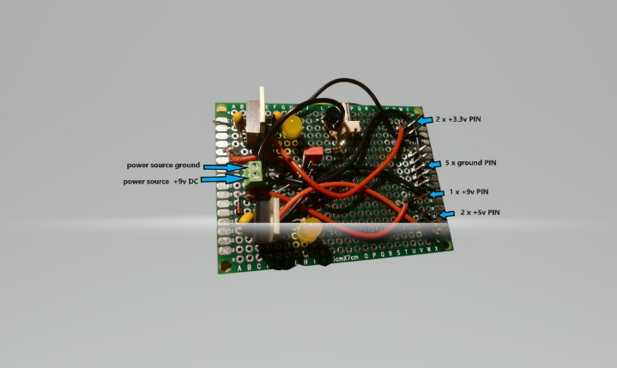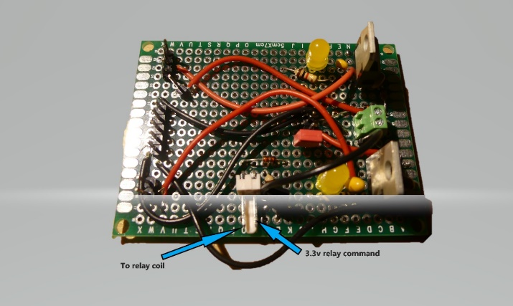

|  |  |
| --- | --- |
|  |  |

You can see below the parts numbers according to the Fritzing model.

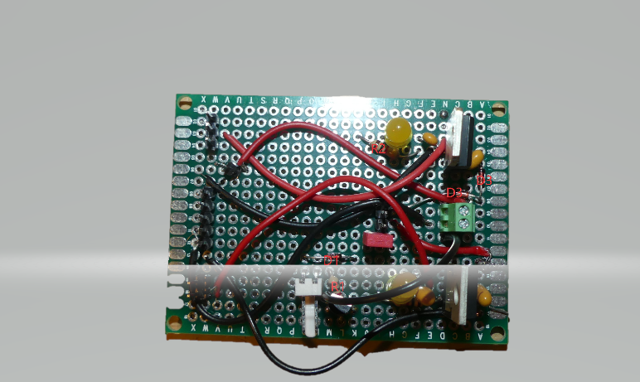

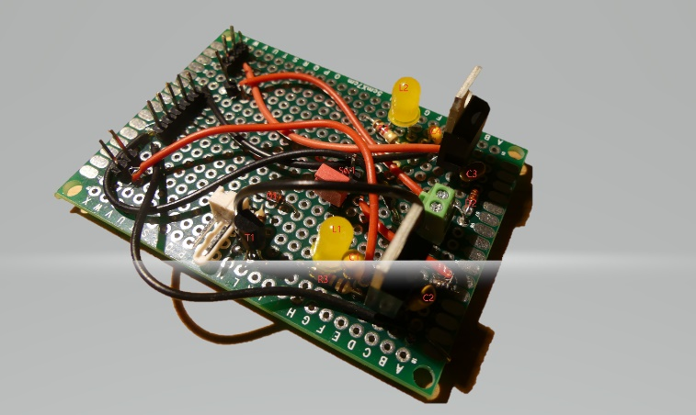Solder the microcontrollers on PCB

[Here is the Frizting scheme to follow !](https://github.com/cuillerj/Thermostat/blob/master/thermostatElectronicDesign.fzz)

You will need connectors for:

* 3 x +5v (I did one spare)
* 6 x ground
* 3 x for DS1820
* 3 x for LED
* 1 x IR receiver
* 2 x for relay command
* 4 x for I2C bus

I suggest not soldering the Arduino and ESP8266 directly on the PCB

Instead use connectors as below in order to be able to replace easily the microcontrollers

.

|  |  |
| --- | --- |
| C:\Users\jean\AppData\Local\Microsoft\Windows\INetCache\Content.Word\P1020323.jpg | C:\Users\jean\AppData\Local\Microsoft\Windows\INetCache\Content.Word\P1020324.jpg |

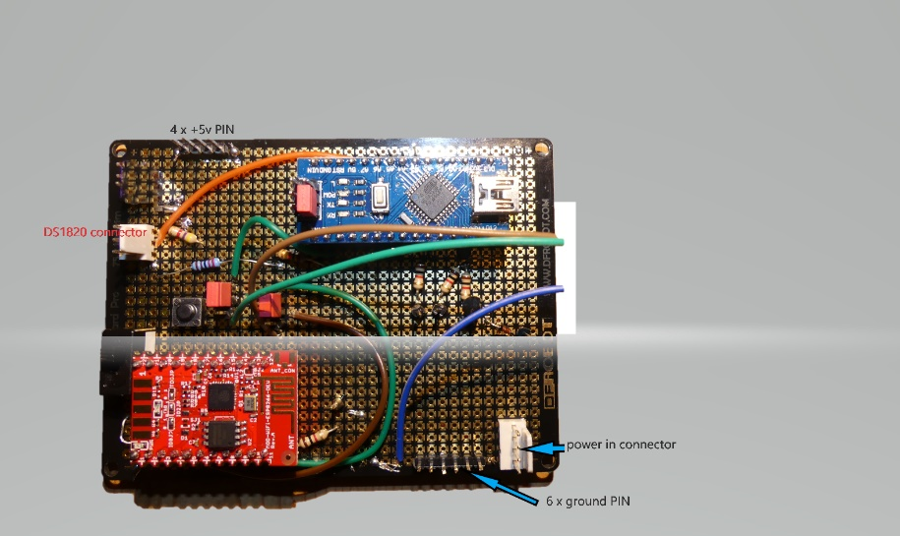

You can see below the parts numbers according to the Fritzing model.

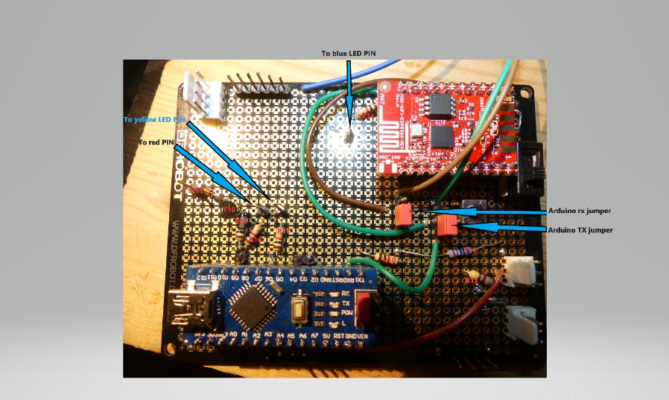

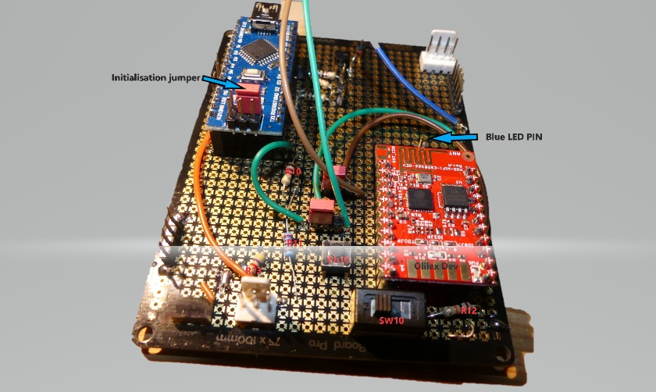

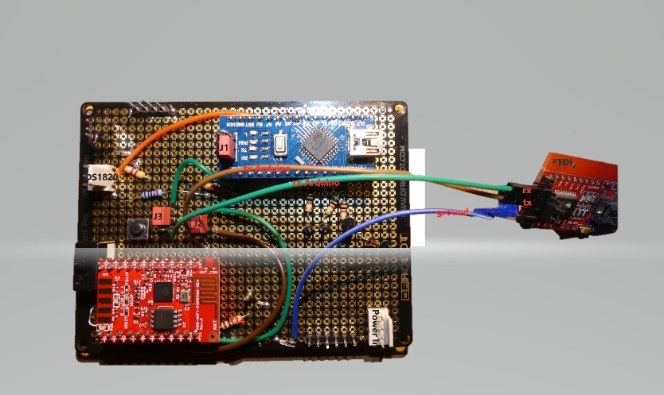

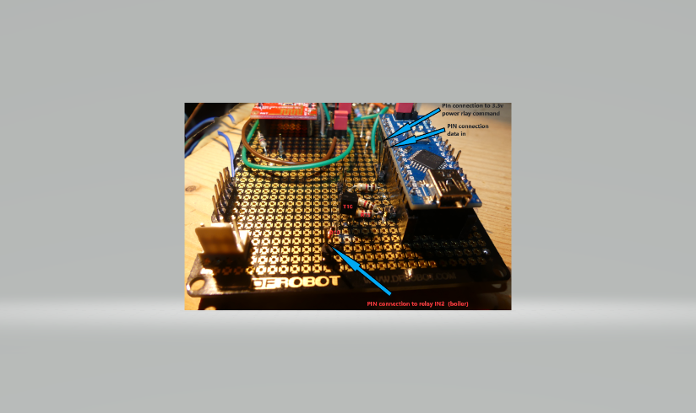

## 

The I2C connection

Connect and check altogether before putting in the box

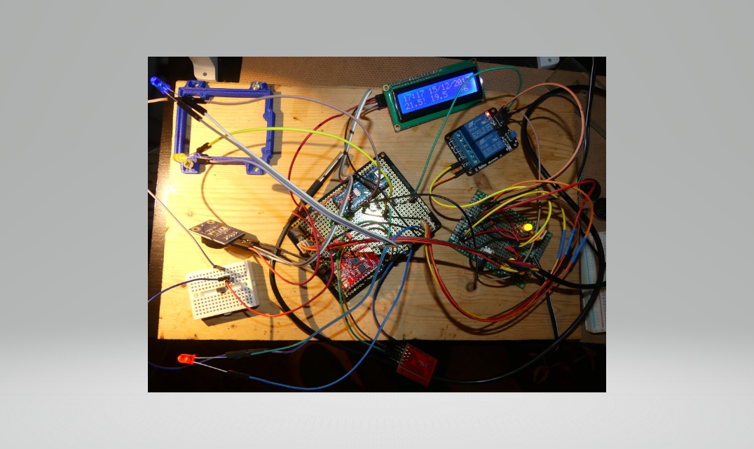

Add some colored sticks to do it easy to reconnect

|  |  |  |
| --- | --- | --- |
| C:\Users\jean\AppData\Local\Microsoft\Windows\INetCache\Content.Word\P1020318.jpg | C:\Users\jean\AppData\Local\Microsoft\Windows\INetCache\Content.Word\P1020317.jpg | C:\Users\jean\AppData\Local\Microsoft\Windows\INetCache\Content.Word\P1020314.jpg |

Screw PCBs on a piece of wood

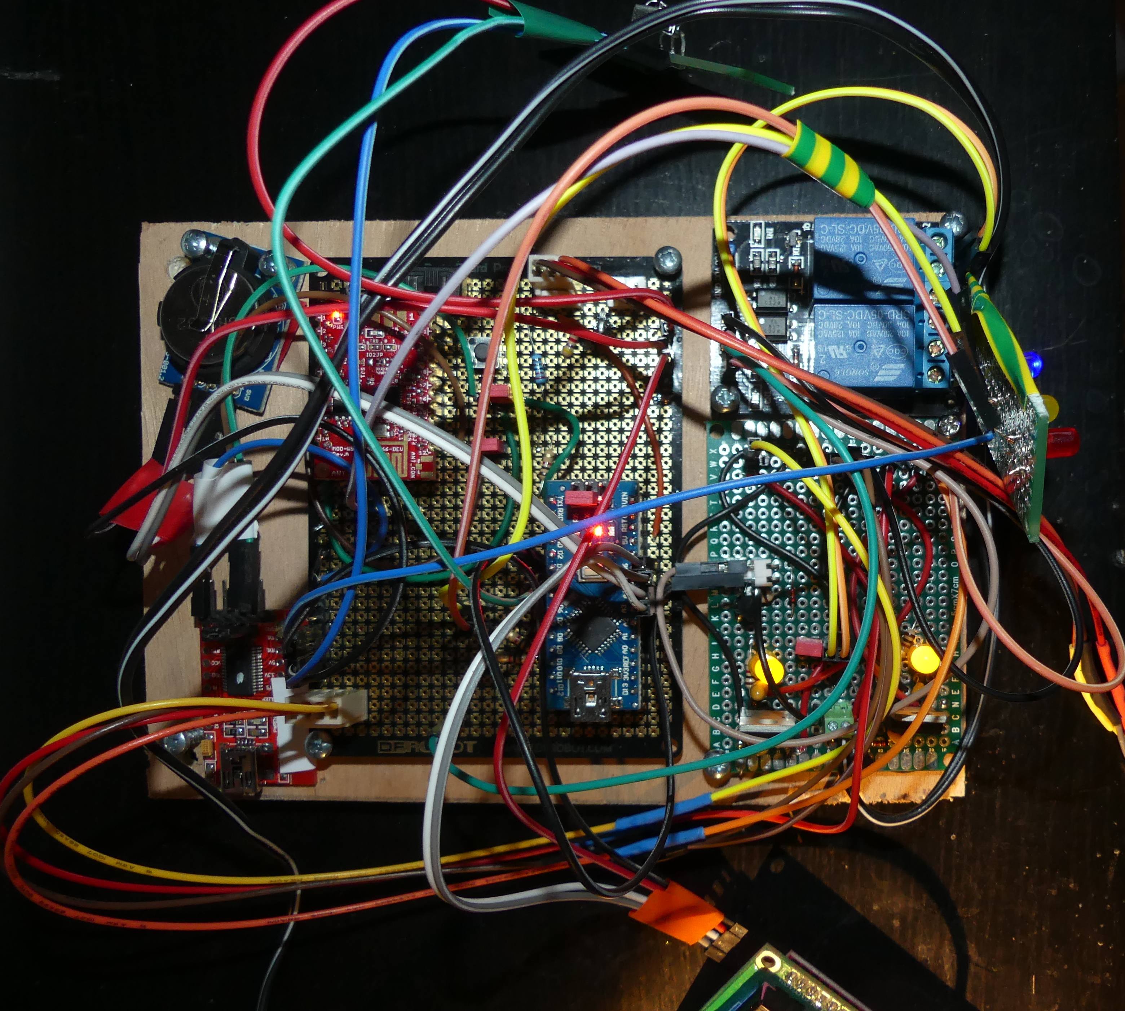

#### Let’s do the wooden cover box

|  |  |
| --- | --- |
| C:\Users\jean\Downloads\IMG_20171228_100412.jpg | C:\Users\jean\Downloads\IMG_20171228_100345.jpg |
| C:\Users\jean\AppData\Local\Microsoft\Windows\INetCache\Content.Word\IMG_20171228_100353.jpg | C:\Users\jean\AppData\Local\Microsoft\Windows\INetCache\Content.Word\IMG_20171228_100418.jpg |

Put all in the box

#### 

#### Connect the thermostat to the boiler

Before doing read carefully the boiler instructions. Take care to high voltage.

The thermostat must be connected to a simple contact with a 2 wires cable.

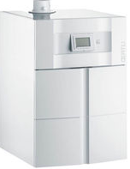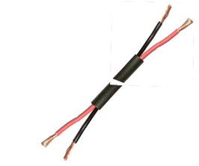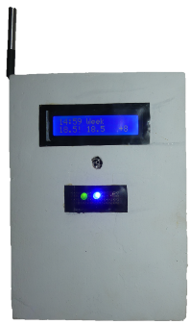

## User guide

|  |  |
| --- | --- |
|  |  |

|  |  |  |
| --- | --- | --- |
| **Action** | **Remote controller** | **Web HMI** |
| Modify current temperature instruction | (+) or (-) to increase or decrease temperature | “Change instruction” |
| Hold on heating | NA | “Hold on heating” |
| Change current running mode\* | |  |  | | --- | --- | |  | Switch off | |  | Week mode | |  | Day1 type mode | |  | Day2 type mode | |  | No freeze mode | | “Change mode” |
| Power on/off WIFI | |  |  | | --- | --- | |  | On/Off | | NA |

|  |  |
| --- | --- |
|  |  |
|  |  |

## How to install the server code

### Start your IDE environment

[Download the batches sources](https://github.com/cuillerj/ThermostatRuntime) from GitHub

[Download the J2EE sources](https://github.com/cuillerj/ThermostatPackage) from GitHub

Start your Java IDE (Eclipse for instance)

Create Java project “ThermostatRuntime”

Import the downloaded batches sources

Create a J2EE project (Dynamic Web Project for Eclipse) “ThermostatPackage”

Import the downloaded J2EE sources

Create a “GelSqlConnection” class in both Java and J2EE project as below with your MySql server user, password and host you will use to store data.

|  |
| --- |
| **public** **class** GetSqlConnection {  **public** **static** **final** String *connectionUser* = "yourUser";  **public** **static** **final** String *connectionPassword* = "yourPassword";  **public** **static** **final** String *domotiqueUrl* = "jdbc:mysql://yourhost:3306/domotiquedata";  **public** **static** **final** String *meteoUrl* = "jdbc:mysql://yourhost:3306/meteo";  **public** **static** String GetUser() {  // **TODO** Auto-generated method stub  **return** *connectionUser*;  }  **public** **static** String GetPass() {  **return** *connectionPassword*;  }  **public** **static** String GetDomotiqueDB() {  **return** *domotiqueUrl*;  }  **public** **static** String GetMeteoDB() {  **return** *meteoUrl*;  }  } |

### Create the database tables

#### Mandatory tables

[Use Sql script to create indDesc table](https://github.com/cuillerj/createMySqlDataBases)

[Use Sql script to create indValue table](https://github.com/cuillerj/createMySqlDataBases)

[Use Sql script to create stations table](https://github.com/cuillerj/createMySqlDataBases)

**Initialize tables**

[​Download loadStations.csv file](https://github.com/cuillerj/createMySqlDataBases)

open the csv file

modify st\_IP to fit with your network configuration.

* the first address is the Thermostat one
* the second Thermostat is the server one

save and load the stations table with this csv

Download loadIndesc.csv

load the ind\_desc table with this csv

#### Optional tables

##### Access security

The thermostat parameters modification is protected with IP authorization table.

You can do whatever control you want by modifying “ValidUser.java” code to fit your need.

You can also create the [Security table](https://github.com/cuillerj/createMySqlDataBases) and insert a record in this table.

|  |  |  |  |
| --- | --- | --- | --- |
| **IpAddress** | **userID** | **date** | **validity** |
| 192.168.1.13 | 1 | 2016-09-13 07:47:48 | 2020-09-13 08:47:48 |

##### Outside temperature

I use this [weather forecast API](http://api.previmeteo.com/) to get information for my location and it works pretty well. A shell with curl hourly extracts temperature and store in database. You can adapt the way you will get the outside temperature by modifying the “KeepUpToDateMeteo.java” code.

##### Home security

I interfaced my home security system with the Thermostat in order to decrease automatically the temperature instruction when I leave home. You can do something similar with the “securityOn” field in the database.

|  |  |  |  |
| --- | --- | --- | --- |
|  |  |  |  |

#### Start the runtime code

Export the ThermostatRuntime project as a jar file

Unless you want to modify UDP ports start batches with the command:

* ​java -cp $CLASSPATH ThermostatDispatcher 1840 1841

CLASSPATH must contain access to your jar file and mysql connector.

You must see something like above in the log.

Add an entry in the crontable to start at reboot

*Start the J2EE code*

Export the ThermostatPackage as a WAR.

Deploy the WAR with the Tomcat manager

Test the application youserver:port/Thermostat/ShowThermostat?station=1

You must see something like this:

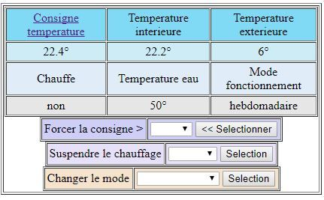

*Synchronize the Thermostat and server*

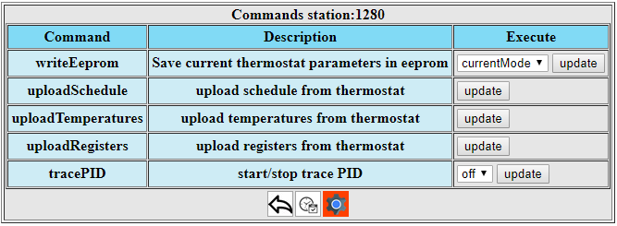

Use the command menu of the HMI to do the following steps

* Upload temperatures
* Upload registers
* Upload schedule
* Write eeprom / select All

## Maintenance guide

### Diagnostic

#### LED meaning

##### Outside the box LEDs

The LEDs provide information on the system status.

|  |  |  |
| --- | --- | --- |
| **Blue LED on: WIFI connection Ok** | **Green LED on: heating on** | **Red LED on: something wrong** |
|  |  |  |

Blue LED off means the WIFI gateway is not ok.

During the start of the system, yellow LED lights on. It can take a few minutes before the yellow LED switch off.

During the normal running mode, the yellow LED on means system that something is wrong. Look at the diagnostic byte for more details.

##### Inside the box LEDs

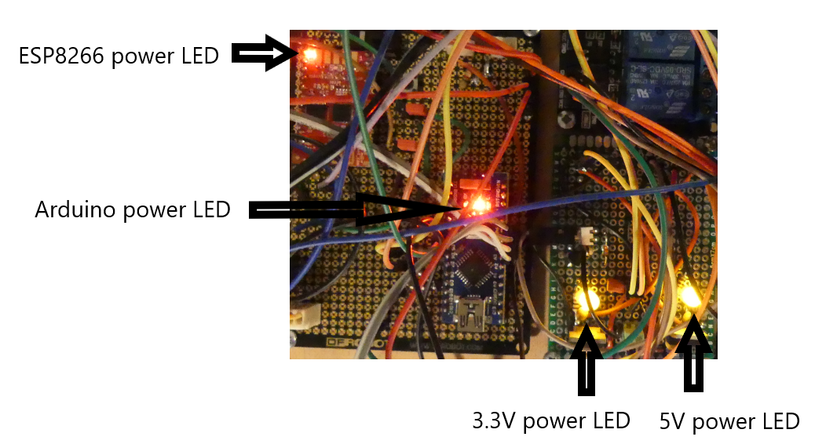

### Diagnostic byte

Diagnostic information is provided with the diagnostic byte. This diagnostic byte can be read on the LCD and on the Web HMI if issue does not relate to the network.

**Diagnostic byte structure**

|  |  |  |  |  |  |  |  |
| --- | --- | --- | --- | --- | --- | --- | --- |
| **Bit 7** | **Bit 6** | **Bit 5** | **Bit 4** | **Bit 3** | **Bit 2** | **Bit 1** | **Bit 0** |
| Eeprom issue | Temperature sensor issue | Temperature ramp up issue | Wifi gateway issue | Connection with server issue | Clock synchronization issue | External temperature issue | Not used |

### Modify WIFI SSID

You need a laptop with a TTY tool (you can use Arduino IDE).

Connect the laptop to the FDTI USB.

Start the TTY and set

Set the serial switches to ESP8266 mode (see how to set serial switches).

Set serial speed 38400 b/s.

Change the SW10 switch to configuration mode

|  |  |
| --- | --- |
| Running mode | Configuration mode |
|  |  |

Refer to the gateway guide to enter commands.

At the end set SW10 and serial switches to running mode.

### Download a new Arduino code.

You need a laptop with Arduino IDE.

Connect the laptop to the Arduino USB.

Start IDE and select port and set card to nano.

Set the serial switches to Arduino downloading mode (see how to set serial switches).

Download code

Set the serial switches to running mode.

### Download a new Gateway code.

You need a laptop with Arduino IDE.

Connect the laptop to the FDTI USB.

Start IDE and select port and set card to ESP8266 (dev Olimex).

Power off the system.

Set the serial switches to ESP8266 mode (see how to set serial switches).

Press on the push button Pb10 and power on the system.

Release the push button.

Download the gateway code.

Set the serial switches to running mode.

### How to set the serial switches

Normally the 2 switches must be set to connect Arduino Tx Rx with Esp8266 Rx Tx (running mode).

For downloading a new Arduino code the 2 switches must be removed in order to avoid conflict with USB transfer.

For downloading a new ESP8266 code or modifying the Gateway configuration the 2 switches must be set to connect FTDI Tx Rx with Esp8266 Rx Tx.

|  |  |  |
| --- | --- | --- |
| Running mode | Arduino downloading mode | ESP8266 FTDI mode |
| C:\Users\jean\AppData\Local\Microsoft\Windows\INetCache\Content.Word\switchSerialNormalMode.jpg | C:\Users\jean\AppData\Local\Microsoft\Windows\INetCache\Content.Word\switchSerialArduinoDownloadMode.jpg | C:\Users\jean\AppData\Local\Microsoft\Windows\INetCache\Content.Word\switchSerialEsp8266Mode.jpg |

### System tunning

To fit your boiler and house characteristics you can tune

* the PID
* the reactivity
* the hysteresis

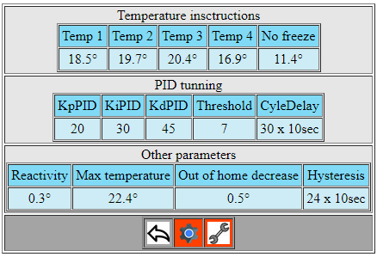

[A PID controller](https://en.wikipedia.org/wiki/PID_controller) is used to regulate the temperature. You can adjust proportional, integral and derivative terms and the threshold. PID result is updated every “CycleDelay”. “CycleDelay” is expressed in minutes and must fit with the duration of a significative change of the inside temperature.

Setting PID Threshold to 255 will disable PID controller. System will switch heating on/off when temperature will be .2°C over or under the instruction.

Reactivity defines the capacity expressed in °C of the heating system to increase the temperature of your house in 30 minutes when outside temperature is 10°C. It depends of the boiler, radiators and size of the rooms.

The “hysteresis” is expressed in minutes and defines the minimum delay between 2 boilers on/off switches. It must be consistent with de “CycleDelay”.

In order to tune those parameters you can start a PID trace (see Commands). Data will be stored continuously in the “PIDdata” SQL table. Let it run a few days. Afterward you will have enough data to analyse you system behaviour improve tuning.

Modify the parameters with the HMI. Take care that each one is byte coded so cannot exceed 255.

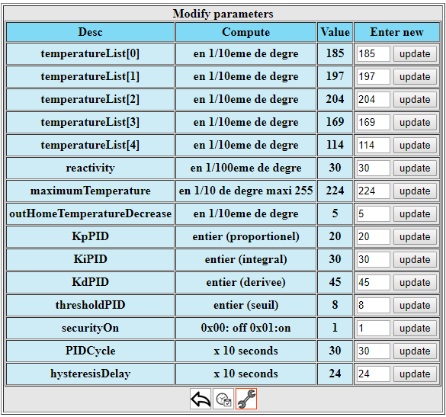

It can take a couple of minutes for the thermostat to update the parameters values.

|  |  |
| --- | --- |
| Threshold update pending | Threshold update completed |
|  |  |

### Commands

Some additional commands are available.

* writeEeprom to save in the thermostat eeprom, the current running mode as default, the 5 temperature instructions, the current PID and other parameters (registers) and the current schedule.

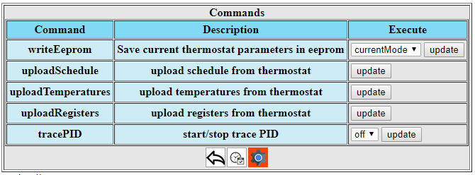

## An open system

### Change than can be done easily

Replace internet weather forecast by a DIY external temperature sensor.

Replace Linux server with a Windows one.

Replace the wooden box by 3D printed one.

Replace Internet weather forecast by your own temperature sensor.

Run Java code on a Windows server.

### Improvements that could be done

Replace the breadboard PCB with a printed PCB.

### Communication specifications

The ESp8266 Serial/UDP gateway allows to route up to 30 bytes. No other constraints for ASCII data. Regarding binary data it can send any 2 consecutive bytes. Those 3 consecutive bytes "0x7f7f7f & 0x7f7e7f" that are forbidden.

|  |  |  |  |  |  |  |  |  |
| --- | --- | --- | --- | --- | --- | --- | --- | --- |
| serial link level | | | UDP Level | | | | | |
| 0x7f | 0x7e | 0x7f | FNumber | 0x00 | Req | 0x00 | FLen | DataBytes |

FNumber: frame number modulo 256

Req format:

* the bit b1000 0000 determines request or response frame
* the bit b0100 0000 determines if the frame has to be acknowledged or not
* the bit b0000 0001 reserved

FLen: number if bytes at UDP level

|  |  |  |  |  |
| --- | --- | --- | --- | --- |
| DataBytes | | | | |
| unitG | unitID | Cmd | Data bytes | CRC |

unitG: 1 byte unit group unitID: 1 byte unit number 256\*unitG + unitID = the thermostat identifier

Cmd: 1 byte command identifier (commands list are defined in ThermostatDefines.h)

CRC: 1 byte CRC